Task : - Using Homeseer (HS) SDK, create simple plug-in called "Matter" that displays a single web page and does two things only  
  
1. Creates HS device from text entered at the web page.  
2. Displays text on the web page that was sent from HS event/action.

For the given task we do following approach

* Understand the Requirements
* Review the task provided by the client.

1. To Know about Homeseer (HS) SDK
2. What is Matter?
3. Why build with Matter?
4. What are the considerations when building with Matter?
5. Why use Homeseer API?
6. How to Communicate with Homeseer API?
7. How to create HomeseerPlugin?
8. Which Package is use for the Homeseer SDK?
9. How to communicate with Client side and Server side?

* Refer the Document for Understanding Matter like

<https://developers.home.google.com/matter/overview>

<https://homeseer.com/>

To perform the given task, we create Dot net framework Solution

In that we add new project (ASP.NET MVC)

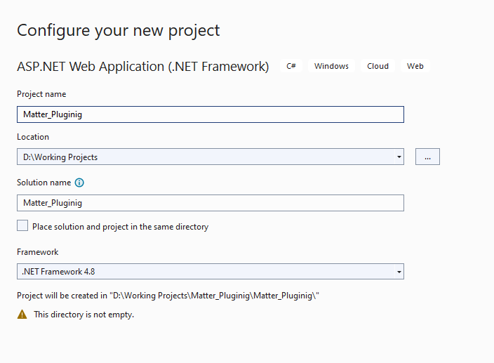

After adding the MVC project add the necessary NuGet Packages  
1) Homeseer-Plugin SDK

2) homeseer3

above packages are the version specific

In dot net project select Dot net framework version like 4.6.1,4.6.2 up to 4.8.1

Now create one Controller : Home Controller

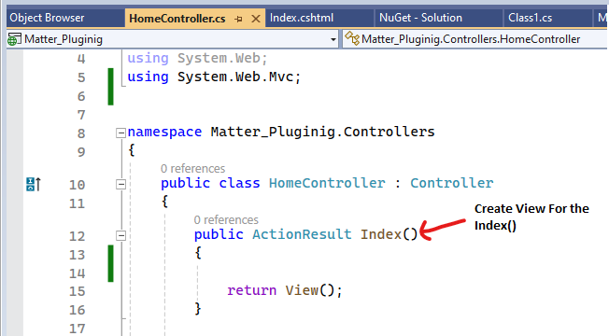

Below code is for how to communicate with client side and how to call Plugin

In the above code we design one Textbox and one Submit Button for client-side communication

Now we can create new Class Library Project for Server-Side Communication  
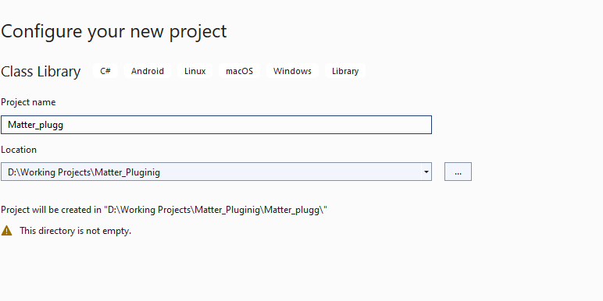

In this project we add multiple references like

1)HomeSeerAPI

2)Scheduler  
  
Now we can add one class for create a Plugin.

We used IPlugInAPI for override Homeseer methods.

Below Is the steps for HS4 download.

We download the Homeseer HS4 Free, but Shipping charge required.

After Install the exe below HS4 Registration Required

